## **Objectives**

* Explain about conditional rendering in React
* Define element variables
* Explain how to prevent components from rendering

In this hands-on lab, you will learn how to:

* Implement conditional rendering in React applications

## **Prerequisites**

The following is required to complete this hands-on lab:

* Node.js
* NPM
* Visual Studio Code

## **Notes**

Estimated time to complete this lab: **60 minutes.**

Create a React Application named “ticketbookingapp” where the guest user can browse the page where the flight details are displayed whereas the logged in user only can book tickets.

The Login and Logout buttons should accordingly display different pages. Once the user is logged in the User page should be displayed. When the user clicks on Logout, the Guest page should be displayed.

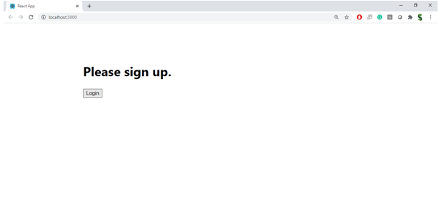

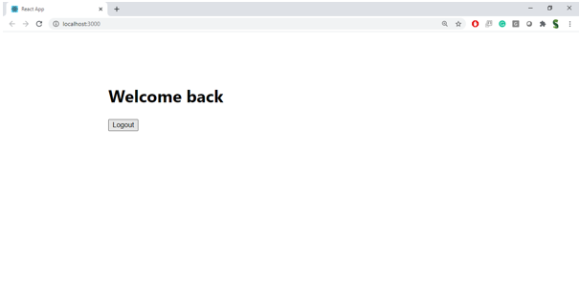

**Hint:**

